*Bike Ecommerce*

software development document

Version *1.0*

*07/20/2022*

**Team Members**

|  |  |
| --- | --- |
| **Name** | **ID** |
| **Md. Reaz Uddin Chowdhury** | **21-92155-3** |
| **Ummey Soaiba Yeasmin** | **21-92158-3** |
| **Akibur Rahman Akib** | **22-92573-2** |
| **Sheuly Akter** | **22-92609-2** |
| **Md. Rifat-Uz-Zaman** | **22-92610-2** |

***OVERVIEW***

The Software Development Document required to effectively defining the approach to be used in the document of the project’s product with the necessary information. The document is created during the Development Phase of the project. Its intended audience is the project manager, project team, and testing team. Some portions of this document may on occasion be shared with the client/user and other stakeholders whose input/approval into the developing process is needed.

***Unit’s functionality***

Unit tests are typically automated tests written and run by software developers to ensure that a section of an application (known as the "unit") meets its design and behaves as intended. In procedural programming, a unit could be an entire module, but it is more commonly an individual function or procedure. Therefore for this software or site also ensure with its accurate application with best design.

***Development methodologies***

Here, the Agile methodology and more specifically Scrum was used during the Development process where the requirements have been divided into tasks. Each sprint was one week long. It was estimated that it would require 16 sprints to complete development. Trello was used as a scrum board for collaboration and to keep track of progress.

***The Functional Requirements Document***

#### Admin Functional Requirement:

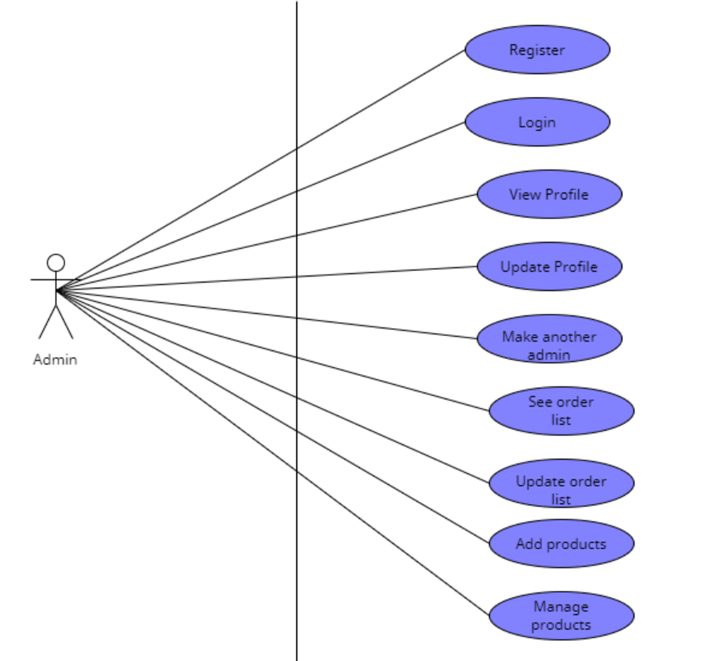

Fig 1: Admin Functional Requirement

The functional requirement of an admin is as follows:

The Admin shall be able to login using by filling up the email and password field  
The Admin shall be able to able to create a new admin by inputting his email  
The Admin shall be able to view orders made by a customer   
The Admin shall be able to change the status of an order using a dropdown  
The Admin shall be able to add a new product by inputting the product details in a form  
The Admin shall be able to delete products by clicking the delete button on a product

#### Customer Functional Requirement:

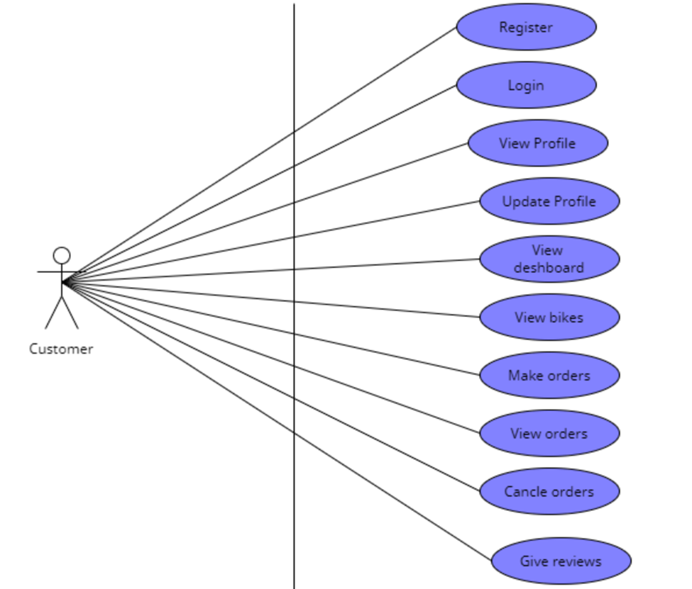

Fig 2: Customer Functional Requirement

The functional requirement of Customer is such as:

The user shall be able to order a bike by filling out name phone and address input fields   
The User shall be able to change profile details by changing the text field and clicking on update   
The user shall be able to login using google login  
The user shall be able to register using email and password   
The user shall be able to view order status in his profile

***The functional requirements in the test plan***

**For Customer:**

|  |  |  |  |
| --- | --- | --- | --- |
| **Item to Test** | **Test Description** | **Test Date** | **Responsibility** |
| Registration | The first way to enter this software is to do the registration. Tester will do demo data to complete the registration. Tester will check whether the OTP is being send to the mail. Tester will also check the mail account must include @gmail.com. If there have some problems in OTP like sometimes there has some network issue for that reason OTP send in delay then tester will provide notification. If all those information shows valid then the tester will check that the page is moving to the login page or not. | 20-06-22 | Developer |
| Login | For customer login, the provided data will be collected by the tester. Then the tester will give the input of that id and password. If the id and password matched with the system-defined admin I'd and password it will move to the system menu page. The tester will taste if it is working fine or not and also, he will check about the forget password option too. Whether the OTP is sending to the proper email or not. And If it is successful he will check whether it is notifying or not. | 26-06-22 | Developer |
| View Profile | Completing the log in the tester will check is this the customer menu or a customer view. If there is some problem then it will move to the do phase again. Tester will check that in the profile every specified button is working properly or not. Will recheck that the customer can view all the system information and specifications. | 27-06-22 | Designer |
| Update Profile | For updating the profile tester will check whether it is linked up the mail to the registration Gmail in the system. For that tester will check that the system is sending the correct OTP to the correct Gmail. And after putting that specific OTP message the system is allowed to complete the update profile. Here the tester will work with predefined demo data for the customer update profile and also make sure that the update will be done in the system also. | 27-06-22 | Developer |
| View Dashboard | The tester will log as a customer to the system and then will try to see the dashboard. If the dashboard is working properly then it will show the all details of previously ordered items in the system. If the Tester found any problem in the dashboard like some portion is not working or some are not visible then the work will move to do. | 27-06-22 | Developer |
| Make Order | To make an order, the Tester will place a demo order to the system. Then the tester will check that is the order placed successfully or not. Then the tester will also check that the order quantity order item ID and order details are matching with the placed order or not. And finally, after providing the order the tester will check whether the quantity decreased in the system or not. | 27-06-22 | Developer |
| View Order | For the customer, the view order tester will check whether the tester is logged as a customer or not. In order to view the order, the list tester will taste whether the order I'd and the product information is the same or not. The tester will also go through that the specific order is showing to the specific customer and the row should be appropriately stored. The tester will also check the order date and mage it with the order information. | 28-06-22 | Developer |
| Cancel Order | To cancel the order Tester will check whether the system is logged as a customer. Then the tester will check if the customer's request to cancel the order is this going for admin approval or not. If it's not then it will have some issues. the tester will check that by providing the valid information is the order being canceled or not. For that, the tester will check the admin phase as well. | 28-06-22 | Developer |
| Give Review | To store new reviews about the product in the system Tester will check whether it is overlapping with the existing review products. Then the tester will check that after providing the review it is visible to the system or not. The tester will also check whether the review is going for admin approval or not. | 29-06-22 | Developer |

**For Admin:**

|  |  |  |  |
| --- | --- | --- | --- |
| **Item to Test** | **Test Description** | **Test Date** | **Responsibility** |
| Registration | For admin registration all information will be stored in the system. So tester have to ensure that the data is storing in the system is working properly during to the login time and updating time. System will read data automatically from the stored information. Of the admin to make successful registration for the admin. Tester have that duty to ensure the safety of data duplication and ensure the system can read data automatically. | 20-06-22 | Developer |
| Login | For admin login the predefined data will be collected by the tester. Then the tester will give the input of that id and password. If the id and password matched with the system defined admin, I'd and password the it will move to the system menu page. Tester will taste that it is working fine or not and also, he will check about the forget password option too. Like the OTP is sending to the proper email or not. And If it is successful the he will check whether it is notifying or not. | 21-06-22 | Developer |
| View Profile | Completing the log in the tester will check is this the admin menu or a customer view. If there is some problem then it will move to the do phase again. Tester will check that in the profile every specified button is working properly or not. | 21-6-22 | Developer |
| Update Profile | For updating the profile tester will link up the mail to the predefined admin Gmail in the system. For that tester will check that the system is sending the correct OTP to the correct Gmail. And after putting that specific OTP message the system is allowed to complete the update profile. Here the tester will work with predefined demo data for the admin update profile and also make sure that the update will be done in the predefined system also. | 21-6-22 | Designer |
| Make Another Admin | In this testing phase tester will identify whether the person is trying to make another admin is this the predefined system admin or not. and before making another admin tester will see whether the admin has filled all necessary information about the new admin or not. If it is successful then the tester will check is it working to update the admin panel in the system or not. And after successful completion the data of the new admin is being stored in the system or not will be checked by the tester also. | 22-6-22 | Developer |
| View Order list | For admin, the view order tester will check whether the tester is in logged as admin or not. In order to view the order, the list tester will taste whether the order I'd and the product information is the same or not. The tester will also go through that the specific order belongs to the specific customer and the row should be appropriately stored. The tester will also check the order date and mage it with the order information. | 23-6-22 | Designer |
| Update Order list | To update the order list Tester will check whether the system is logged as admin. Then the tester will check the order update and order condition that is the order condition shows the updated version or not. If the version is updated the tester gives to allow the admin for further work as updates are deleted or replace. | 23-6-22 | Developer |
| Add New Products | To add a new product to the system Tester will check whether it is overlapping with the existing products. Then the tester will check the availability of the quantity of that product also and Will also check that after adding products, it is visible to the system or not. | 24-6-22 | Designer |
| Manage Products | Manage the existing products in the system tester will check whether those products are available or not. He will check whether the system is proving the latest update or not. The taster will recheck the System is giving proper updates about processing, delivery, order, etc. The tester will also justify whether the managed product is showing properly in the system or not. | 25-6-22 | Developer |

***Source code listing***

<https://github.com/Akibur/ranger-bike-msc>

***Controlled libraries/directories/tables***

[*https://github.com/Akibur/ranger-bike-msc*](https://github.com/Akibur/ranger-bike-msc)

***Unit test results and analysis***

**st r**

**For Customer:**

**Registration:** If all customer information is filled properly according to the guidelines like email must contain @gmail, the name will start by alphabet, etc. Then it will pass otherwise fail.

**Login:** If the login id and password match with the registered customer id and password then it will pass otherwise fail. Another way is if the forget password works with the OTP it is passed otherwise fails.

**View Profile:** If the customer login is successful then the view profile will work and if all features work properly in the profile, then it is passed otherwise fail.

**Update Profile:** If the email address is confirmed as the registered Gmail, then it passed and if it is not then fails.

**View Dashboard:** If the Customer order list is visible to the system and works regularly then it passed otherwise fails.

**Make Order:** If the ordered products are available and it moved to the purchase option then it passed it not then fail.

**View Order:** If a customer order is placed successfully then the view order is visible and passed also but if it is not then it failed.

**Cancel Order:** If the Customer filled the canceled order form with a valid reason then it will pass and move to the next and if the form is not filled then it will fail.

**Give Review:** If customer products are delivered successfully then the customer can fill the review form for admin approval if the form is filled then the phase is passed otherwise failed.

**For Admin:**

**Registration:** If all admin information is filled properly according to the guidelines like email must contain @gmail, the name will start by alphabet, etc. Then it will pass otherwise fail.

**Login:** If the login id and password match with the registered admin id and password then it will pass otherwise fail. Another way is if the forget password works with the OTP it is passed otherwise fails.

**View Profile:** If the admin login is successful then the view profile will work and if all features work properly in the profile, then it is passed otherwise fail.

**Update Profile:** If the email address is confirmed as the registered Gmail, then it passed and if it is not then fails.

**Make Another Admin:** Registered admin can make admin by providing admin form if it is properly filled with the requirement then it will pass otherwise fail.

**View Order list:** Admin can view order list when an order is confirmed by customer and then the test will pass otherwise fail.

**Update Order list:** Admin can update order list like order condition, order time, order date etc. when an order is confirmed by customer and then the test will pass otherwise fail.

**Add New Products:** Admin can add new product by providing product information like name, id, quantity etc. and if all these fields are complete then it is passed otherwise failed.

**Manage Products:** Admin can manage product by using the product manage way if it is successful then the test is passed otherwise failed.

# ROLES AND RESPONSIBILITIES

Theteam members have the following roles and responsibilities:

* The application developer assigned the primary responsibility for the module or unit creates a file folder for the unit, labels it according to the name of the unit, and places it in the appropriate place in the project team file cabinet.
* The application developer(s) add copies of the indicated documentation to the folder as they are created.
* The project QA representative reviews the contents of the folder for completeness, and points out discrepancies to the developer assigned primary responsibility for tile module or unit.
* The developer assigned primary responsibility for the module or unit completes the Software Development Document Check-Off sheet and arranges for the System Technical Lead review and approval when needed.
* The folder is available to all project team member for review, but if removed from the file cabinet, it must be replaced with a cheek-out card indicating who checked it out, when, and where it will he located.

# PROCESS

The following sections are consisting of the Check-Off sheet:

* **Requirements –**

For the Bike Ecommerce Store, we need some specific requirements such as

* External interfaces,
* Functions (admin functionality, and customer functionality),
* Performance,
* Lgical database,
* Design constraints (standards compliance),
* Software system attributes, and
* Organizing the specific

All mentioned things are describe into the software requirements specification document. Here the significant thing is all those things are justified and comes with outstanding outcome.

* **Functionality –**

**For Customer:**

|  |  |  |  |  |
| --- | --- | --- | --- | --- |
| **Checkmark** | **Item to Test** | **Test Description** | **Test Date** | **Responsibility** |
|  | Registration | Must full fill all valid information and must sent OTP to assign number for confirming account. | 22/06/2022 | Developer |
|  | Login | Using valid user id and password avail to see dashboard | 22/06/2022 | Developer |
|  | View Profile | Can avail to see their given information in a tabular form that saves into the database | 24/06/2022 | Developer |
|  | Update Profile | Changing details accepted, saves into the database and gives notification | 26/06/2022 | Developer |
|  | View Dashboard | Can able to view and scroll bikes details from the system | 26/06/2022 | Developer |
|  | Make Order | Without any hassle, capable to make order and also get notify | 27/06/2022 | Developer |
|  | View Order | Avail to see place order with exact time, date, place by storing a tabular form | 29/06/2022 | Developer |
|  | Cancel Order | New order will be accepted and get notify | 29/06/2022 | Developer |
|  | Give Review | Submitting reviews store by a tabular form and admin monitor or get notify | 1/07/2022 | Developer |

**For Admin:**

|  |  |  |  |  |
| --- | --- | --- | --- | --- |
| **Checkmark** | **Item to Test** | **Test Description** | **Test Date** | **Responsibility** |
|  | Registration | Full filling valid information and OTP sent to assign number for confirming account. | 1/07/2022 | Developer |
|  | Login | Giving valid user id and password avail to see dashboard | 2/07/2022 | Developer |
|  | View Profile | Avail to see given information in a tabular form that saves into the database | 4/07/2022 | Developer |
|  | Update Profile | Newer details accepted, saves into the database and gives notification | 7/07/2022 | Developer |
|  | Make Another Admin | Capable to save new admin information and get notify both admin | 8/07/2022 | Developer |
|  | View Order list | Receiving  order saves into the database with all details | 10/07/2022 | Developer |
|  | Update Order list | Capable to change place order list and notify both admin and customer | 13/07/2022 | Developer |
|  | Add New Products | Adding newly products saves into the database and shown into the dashboard | 15/07/2022 | Developer |
|  | Manage Products | With whole details managing products saves to database by a tabular form and avail to see those into the site | 18/07/2022 | Developer |

* **Source Code –**

<https://github.com/Akibur/ranger-bike-msc>

* **Libraries, Directories, and Tables –**

<https://github.com/Akibur/ranger-bike-msc>

* **Development Methodologies –**

For the Bike Ecommerce Store, here the Agile methodology and more specifically Scrum was used during the Development process where the requirements have been divided into tasks. Each sprint was one week long. It was estimated that it would require 16 sprints to complete development. Trello was used as a scrum board for collaboration and to keep track of progress.

* Agile
* Scrum
* **Test Data –**

During the testing and using all data necessary to conduct testing referenced in this software.

* **Test Analysis –**

**For Customer:**

|  |  |  |  |  |
| --- | --- | --- | --- | --- |
| **Checkmark** | **Item to Test** | **Test Description** | **Test Date** | **Responsibility** |
|  | Registration | Must full fill all valid information and must sent OTP to assign number for confirming account. | 22/06/2022 | Successfully done with outstanding outcome |
|  | Login | Using valid user id and password avail to see dashboard | 22/06/2022 | Successfully done with outstanding outcome |
|  | View Profile | Can avail to see their given information in a tabular form that saves into the database | 24/06/2022 | Some error detected and go to the developers again |
|  | Update Profile | Changing details accepted, saves into the database and gives notification | 26/06/2022 | Some error detected and go to the developers again |
|  | View Dashboard | Can able to view and scroll bikes details from the system | 26/06/2022 | Successfully done with outstanding outcome |
|  | Make Order | Without any hassle, capable to make order and also get notify | 27/06/2022 | Successfully done with outstanding outcome |
|  | View Order | Avail to see place order with exact time, date, place by storing a tabular form | 29/06/2022 | Successfully done with outstanding outcome |
|  | Cancel Order | New order will be accepted and get notify | 29/06/2022 | Some error detected and go to the developers again |
|  | Give Review | Submitting reviews store by a tabular form and admin monitor or get notify | 1/07/2022 | Successfully done with outstanding outcome |

**For Admin:**

|  |  |  |  |  |
| --- | --- | --- | --- | --- |
| **Checkmark** | **Item to Test** | **Test Description** | **Test Date** | **Responsibility** |
|  | Registration | Full filling valid information and OTP sent to assign number for confirming account. | 1/07/2022 | Successfully done with outstanding outcome |
|  | Login | Giving valid user id and password avail to see dashboard | 2/07/2022 | Some error detected and go to the developers again |
|  | View Profile | Avail to see given information in a tabular form that saves into the database | 4/07/2022 | Successfully done with outstanding outcome |
|  | Update Profile | Newer details accepted, saves into the database and gives notification | 7/07/2022 | Successfully done with outstanding outcome |
|  | Make Another Admin | Capable to save new admin information and get notify both admin | 8/07/2022 | Some error detected and go to the developers again |
|  | View Order list | Receiving  order saves into the database with all details | 10/07/2022 | Successfully done with outstanding outcome |
|  | Update Order list | Capable to change place order list and notify both admin and customer | 13/07/2022 | Some error detected and go to the developers again |
|  | Add New Products | Adding newly products saves into the database and shown into the dashboard | 15/07/2022 | Successfully done with outstanding outcome |
|  | Manage Products | With whole details managing products saves to database by a tabular form and avail to see those into the site | 18/07/2022 | Successfully done with outstanding outcome |

* **Sign-Off –**

The sign off date 20-07-2022.

**SOFTWARE DEVELOPMENT FOLDER CHECK-OFF SHEET**

**Requirements**

For the Bike Ecommerce Store, we need some specific requirements such as external interfaces, functions (admin functionality, and customer functionality), performance, logical database, design constraints (standards compliance), software system attributes, and organizing the specific which are describe into the software requirements specification document. Here the significant things is all those things are justified and comes with outstanding outcome.

**Functionality**

**For Customer:**

|  |  |  |  |
| --- | --- | --- | --- |
| **Item to Test** | **Test Description** | **Test Date** | **Responsibility** |
| Registration | The first way to enter this software is to do the registration. Tester will do demo data to complete the registration. Tester will check whether the OTP is being send to the mail. Tester will also check the mail account must include @gmail.com. If there have some problems in OTP like sometimes there has some network issue for that reason OTP send in delay then tester will provide notification. If all those information shows valid then the tester will check that the page is moving to the login page or not. | 20-06-22 | Developer |
| Login | For customer login, the provided data will be collected by the tester. Then the tester will give the input of that id and password. If the id and password matched with the system-defined admin I'd and password it will move to the system menu page. The tester will taste if it is working fine or not and also, he will check about the forget password option too. Whether the OTP is sending to the proper email or not. And If it is successful he will check whether it is notifying or not. | 26-06-22 | Developer |
| View Profile | Completing the log in the tester will check is this the customer menu or a customer view. If there is some problem then it will move to the do phase again. Tester will check that in the profile every specified button is working properly or not. Will recheck that the customer can view all the system information and specifications. | 27-06-22 | Designer |
| Update Profile | For updating the profile tester will check whether it is linked up the mail to the registration Gmail in the system. For that tester will check that the system is sending the correct OTP to the correct Gmail. And after putting that specific OTP message the system is allowed to complete the update profile. Here the tester will work with predefined demo data for the customer update profile and also make sure that the update will be done in the system also. | 27-06-22 | Developer |
| View Dashboard | The tester will log as a customer to the system and then will try to see the dashboard. If the dashboard is working properly then it will show the all details of previously ordered items in the system. If the Tester found any problem in the dashboard like some portion is not working or some are not visible then the work will move to do. | 27-06-22 | Developer |
| Make Order | To make an order, the Tester will place a demo order to the system. Then the tester will check that is the order placed successfully or not. Then the tester will also check that the order quantity order item ID and order details are matching with the placed order or not. And finally, after providing the order the tester will check whether the quantity decreased in the system or not. | 27-06-22 | Developer |
| View Order | For the customer, the view order tester will check whether the tester is logged as a customer or not. In order to view the order, the list tester will taste whether the order I'd and the product information is the same or not. The tester will also go through that the specific order is showing to the specific customer and the row should be appropriately stored. The tester will also check the order date and mage it with the order information. | 28-06-22 | Developer |
| Cancel Order | To cancel the order Tester will check whether the system is logged as a customer. Then the tester will check if the customer's request to cancel the order is this going for admin approval or not. If it's not then it will have some issues. the tester will check that by providing the valid information is the order being canceled or not. For that, the tester will check the admin phase as well. | 28-06-22 | Developer |
| Give Review | To store new reviews about the product in the system Tester will check whether it is overlapping with the existing review products. Then the tester will check that after providing the review it is visible to the system or not. The tester will also check whether the review is going for admin approval or not. | 29-06-22 | Developer |

**For Admin:**

|  |  |  |  |
| --- | --- | --- | --- |
| **Item to Test** | **Test Description** | **Test Date** | **Responsibility** |
| Registration | For admin registration all information will be stored in the system. So tester have to ensure that the data is storing in the system is working properly during to the login time and updating time. System will read data automatically from the stored information. Of the admin to make successful registration for the admin. Tester have that duty to ensure the safety of data duplication and ensure the system can read data automatically. | 20-06-22 | Developer |
| Login | For admin login the predefined data will be collected by the tester. Then the tester will give the input of that id and password. If the id and password matched with the system defined admin, I'd and password the it will move to the system menu page. Tester will taste that it is working fine or not and also, he will check about the forget password option too. Like the OTP is sending to the proper email or not. And If it is successful the he will check whether it is notifying or not. | 21-06-22 | Developer |
| View Profile | Completing the log in the tester will check is this the admin menu or a customer view. If there is some problem then it will move to the do phase again. Tester will check that in the profile every specified button is working properly or not. | 21-6-22 | Developer |
| Update Profile | For updating the profile tester will link up the mail to the predefined admin Gmail in the system. For that tester will check that the system is sending the correct OTP to the correct Gmail. And after putting that specific OTP message the system is allowed to complete the update profile. Here the tester will work with predefined demo data for the admin update profile and also make sure that the update will be done in the predefined system also. | 21-6-22 | Designer |
| Make Another Admin | In this testing phase tester will identify whether the person is trying to make another admin is this the predefined system admin or not. and before making another admin tester will see whether the admin has filled all necessary information about the new admin or not. If it is successful then the tester will check is it working to update the admin panel in the system or not. And after successful completion the data of the new admin is being stored in the system or not will be checked by the tester also. | 22-6-22 | Developer |
| View Order list | For admin, the view order tester will check whether the tester is in logged as admin or not. In order to view the order, the list tester will taste whether the order I'd and the product information is the same or not. The tester will also go through that the specific order belongs to the specific customer and the row should be appropriately stored. The tester will also check the order date and mage it with the order information. | 23-6-22 | Designer |
| Update Order list | To update the order list Tester will check whether the system is logged as admin. Then the tester will check the order update and order condition that is the order condition shows the updated version or not. If the version is updated the tester gives to allow the admin for further work as updates are deleted or replace. | 23-6-22 | Developer |
| Add New Products | To add a new product to the system Tester will check whether it is overlapping with the existing products. Then the tester will check the availability of the quantity of that product also and Will also check that after adding products, it is visible to the system or not. | 24-6-22 | Designer |
| Manage Products | Manage the existing products in the system tester will check whether those products are available or not. He will check whether the system is proving the latest update or not. The taster will recheck the System is giving proper updates about processing, delivery, order, etc. The tester will also justify whether the managed product is showing properly in the system or not. | 25-6-22 | Developer |

**Source Code**

<https://github.com/Akibur/ranger-bike-msc>

**Libraries, Directories, and Tables**

<https://github.com/Akibur/ranger-bike-msc>

**Development Methodologies**

For the Bike Ecommerce Store, here the Agile methodology and more specifically Scrum was used during the Development process where the requirements have been divided into tasks. Each sprint was one week long. It was estimated that it would require 16 sprints to complete development. Trello was used as a scrum board for collaboration and to keep track of progress.

**Test Data**

* During the testing and using all data necessary to conduct testing referenced in this software.

**Test Analysis**

**For Customer:**

|  |  |  |  |
| --- | --- | --- | --- |
| **Item to Test** | **Test Description** | **Test Date** | **Responsibility** |
| Registration | Must full fill all valid information and must sent OTP to assign number for confirming account. | 22/06/2022 | Successfully done with outstanding outcome |
| Login | Using valid user id and password avail to see dashboard | 22/06/2022 | Successfully done with outstanding outcome |
| View Profile | Can avail to see their given information in a tabular form that saves into the database | 24/06/2022 | Some error detected and go to the developers again |
| Update Profile | Changing details accepted, saves into the database and gives notification | 26/06/2022 | Some error detected and go to the developers again |
| View Dashboard | Can able to view and scroll bikes details from the system | 26/06/2022 | Successfully done with outstanding outcome |
| Make Order | Without any hassle, capable to make order and also get notify | 27/06/2022 | Successfully done with outstanding outcome |
| View Order | Avail to see place order with exact time, date, place by storing a tabular form | 29/06/2022 | Successfully done with outstanding outcome |
| Cancel Order | New order will be accepted and get notify | 29/06/2022 | Some error detected and go to the developers again |
| Give Review | Submitting reviews store by a tabular form and admin monitor or get notify | 1/07/2022 | Successfully done with outstanding outcome |

**For Admin:**

|  |  |  |  |
| --- | --- | --- | --- |
| **Item to Test** | **Test Description** | **Test Date** | **Responsibility** |
| Registration | Full filling valid information and OTP sent to assign number for confirming account. | 1/07/2022 | Successfully done with outstanding outcome |
| Login | Giving valid user id and password avail to see dashboard | 2/07/2022 | Some error detected and go to the developers again |
| View Profile | Avail to see given information in a tabular form that saves into the database | 4/07/2022 | Successfully done with outstanding outcome |
| Update Profile | Newer details accepted, saves into the database and gives notification | 7/07/2022 | Successfully done with outstanding outcome |
| Make Another Admin | Capable to save new admin information and get notify both admin | 8/07/2022 | Some error detected and go to the developers again |
| View Order list | Receiving  order saves into the database with all details | 10/07/2022 | Successfully done with outstanding outcome |
| Update Order list | Capable to change place order list and notify both admin and customer | 13/07/2022 | Some error detected and go to the developers again |
| Add New Products | Adding newly products saves into the database and shown into the dashboard | 15/07/2022 | Successfully done with outstanding outcome |
| Manage Products | With whole details managing products saves to database by a tabular form and avail to see those into the site | 18/07/2022 | Successfully done with outstanding outcome |

**System Developer**

I certify that this software development document is complete, the unit _1, 2 defined in this folder has successfully completed development and unit testing, and the unit is ready to be base lined and integrated into the system

Date: 20-07-22

System Developer:

1. MD. RIFAT-UZ-ZAMAN
2. SHEULY AKTER

System Technical Lead Initials:

1. AKIBUR RAHMAN AKIB